Information on tourist spots around Ojiya

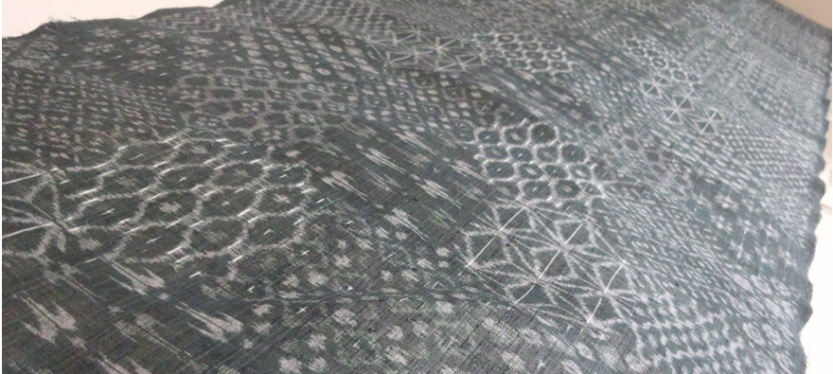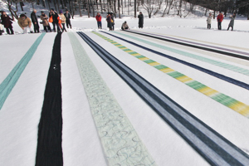
Ojiya Chijimi · Ojiya Tsumugi

- Ojiya Chijimi
Ojiya Chijimi is linen crepe born in Ojiya. The feature of Ojiya Chijimi is its crimped surface called “shibo” made by weaving weft twisting tightly and rubbing the cloth in warm water. Those made with specific traditional making process were designated as a National important intangible property in 1955, a traditional craft by the Ministry of International Trade and Industry in 1975, and the Intangible Cultural Heritage in 2009. Nowadays the procedure has been mechanized, enabling producing more products with stable quality, and also we can enjoy more variations of color and pattern. Ojiya chijimi was originally for summer kimono and yukata, but it has been widely used for Western clothing and accessories for its refreshing coolness and comfortable texture to wear.
- Ojiya Tsumugi
Ojiya tsumugi is silk fabric made by using the technique of Ojiya chijimi. It started in Edo period using dupion silk. Over the years many kinds of silk threads such as silk floss thread have been used for better texture and gorgeous splashed patterns with delicate curves have become popular. Solid color, stripes, splash, and plain white are common patterns for Ojiya tsumugi.
It is designated as a traditional craft.
Episode
Bokushi Suzuki, a writer in the late Edo period, tells about Ojiya chijimi in his masterpiece “Hokuetsuseppu” which explains about his life in a snowy area of Echigo, “spin threads in snow season, weave in snow season, rub in snow water and bleach in the snow. No snow no Ojiya chijimi. Snow is the father of Ojiya chijimi.” Time changes, but Ojiya chijimi still lives with the snow.

